Chilli studios
Health & Safety Policy

[Created 01-10-2015]
Date Modified: 24-04-16
Modified by: Nikki Heeley

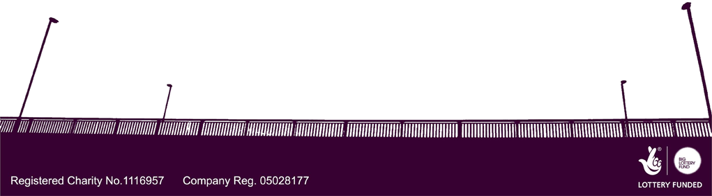
This is the statement of general policy and arrangements for: | Chilli studios
Mr Bob Malpiedi (Studio Manager) | Has overall and final responsibility for health and safety
All staff, Volunteers, and Members | Have the day-to-day responsibility for ensuring this policy into practice`

Statement of general policy | Responsibility of:  Name/Title | Action/Arrangements (What are you going to do?)
Prevent accidents & cases of work-related ill health by managing the health & safety risks in the workplace | Studio Manager, Arts & Admin Project Worker, & Shop co-ordinator | Complete regular risk assessments & follow studio policy for health & safety
Provide clear instructions, information & adequate training to ensure workers are competent to do their work | Studio Manager, Shop co-ordinator | Provide access to policy documents outlining requirements of each post & identify areas necessary for training
Engage & consult with employees on day-to-day health & safety conditions | Studio Manager, Arts project Worker, Shop co-ordinator | Ensure time is taken to manage knowledge of health & safety regulations
Implement emergency procedures – evacuation in case of fire etc. | SVP Management, Studio Manager | Weekly fire alarm tests & ensure all are aware of emergency procedures
Maintain safe & healthy working conditions, provide & maintain studio, equipment & machinery, & ensure safe storage/use of substances | SVP Management/Care-takers, All studio staff & Volunteers | Provide training for equipment and the use of potentially harmful substances and provide a safe storage place for materials

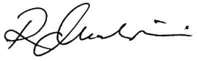  Employer  Signature: | Employer  Printed: Mr Robert Malpiedi | Date: | 04/01/2016

